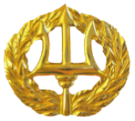**Message from the Commanding Officer**

It is hard to believe 2020 is just around the corner. This year we made fundamental changes to the curriculum and I can honestly say we are producing better technically and tactically trained Hospital Corpsmen. It is because of your dedication and hard work that the next generation of FMF HMs will save lives.

I would like to welcome our new URC; HMC Angela Branch and thank HMC Rosalind Thomas. HMC Thomas provided excellent support during her tenure and I am confident HMC Branch will continue to provide wonderful support to our Command.

I trust you all will take the break between classes to spend time with family and friends and enjoy the holiday season.

The recreation committee worked tirelessly all year to be able to have a magnificent Holiday Party at the Wild Animal Park. I always enjoy seeing everyone and especially enjoy how much fun the kids have. I trust you enjoyed the party as much as my family and I.

THANK YOU for your continued dedication to our FMTB-W Family, each and every one of you all are essential to our success!

Semper Fidelis

CAPT Michael Enriquez

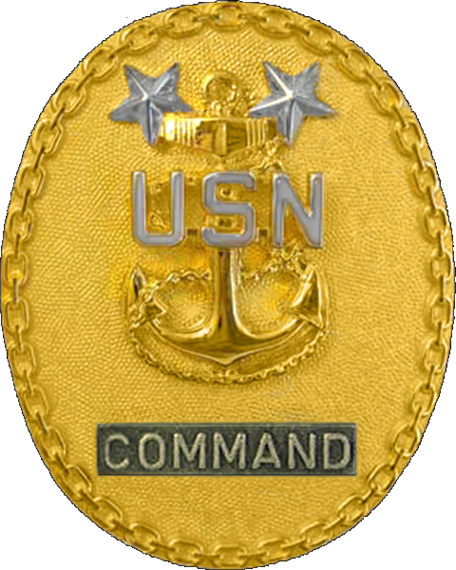**Message from the**

**Command Master Chief**

Happy New Year! I hope 2020 finds you and your families happy and healthy. We had some rain that made training interesting. It was good to see everyone at the holiday party, celebrate after our last class of the year and have a little down time with the family.

There will be some new challenges with running and FMST and FMSO courses at the same time, but I know our staff will knock them both out of the park. The staff here is amazing and continues to impress me every day.

Semper Fidelis

Master Chief Reese Ritter

**Message from the Uniformed Readiness Coordinator**

Greetings FMTB Family! I would like to introduce myself to those that don’t know me. My name is HMC Angela Branch, I am taking over for Chief Thomas as the Uniformed Readiness Coordinator. I would like to express gratitude towards Chief Thomas’s hard work and dedicated hours to promote awareness and family readiness for our families and staff. Gratefully, Chief Thomas is not leaving us yet, she is continuing to support FMTB-West as the Course Chief. We wish her nothing but success for her future endeavors.

I look forward to serving you and your family, please don’t hesitate to reach out to me.

Semper Fidelis

HMC(FMF/AW/SW/SCW) Branch

HMC Angela Branch

(760) 725-2672

**Resources in the Spotlight**

**MCCS News**

For an update of events go to:

<http://www.mccscp.com/events/>

**L.I.N.K.S.**

LINKS is a tool made up of different workshops that is offered to military families to help them understand how to navigate the military life. LINKS is an acronym; it is broken down as follows:

– Understand the military **Lifestyle**.

– Share **Insights** with those who were born, sworn, or married into the USMC.

– **Network** with and strengthen your relationships within the military family.

– Gain **Knowledge** about the Marine Corps history and culture.

– Recognize your **Skills** and learn how to invest in your community.

For more information about the classes that are offered you can call (760) 763-7890 or go online at [www.mccscp.com/lifeskills](http://www.mccscp.com/lifeskills).

**Life Skills Classes:**

Overview: Emphasizing relationship building, communication skills or personal growth; every workshop offers an open and highly interactive atmosphere, where participants are in the driver’s seat. Classes are geared toward every demographic, catering to those who are single, married, or anywhere in between. With curriculum designed by bestselling authors and highly acclaimed personal development groups, these workshops can generate results that impact every aspect of a participant’s life.

**Useful Resources**

For information regarding all aspects of military life, as well as free resources to help in moving, relocating, and everyday life, visit this website: www.militaryonesource.com.

If you or someone you know in the military has an exceptional family member, there are resources available on base. The following website has answers to the concerns many families face: <http://www.mccscp.com/efmp/>

The Navy-Marine Corps Relief Society exists to assist Navy and Marine Corps personnel and their families in times of need. They provide visiting nurses, well baby clinics, budget counseling, quick assist loans and financial information. For information on their services or to request assistance, please contact them at: CampPendleton@nmcrs.org or (760)725-5337.

Are you relocating soon? Would you like information about your next duty station? The Marine Corps Community Services Base and Community Information and Referral Program has the information you need and more. Simply visit the following website for information regarding these issues and much more: <http://www.mccscamppendleton.com/>.

The New Parent Support Home Visitation Program (NPSHVP) is a free support service program designed to meet the needs of expectant active-duty military personnel, their spouses and those families with children under the age of four. The program is to provide prenatal and parenting skills education to active-duty service members and their families.

<https://www.cnic.navy.mil/ffr/family_readiness/fleet_and_family_support_program/counseling-advocacy-and-prevention/new_parent_support.html>

For information regarding your TRICARE enrollment, eligibility, health plan, dental plan or special programs, log in to the following link: <https://tricare.mil/>.



**Single Marine Program**:

To see a schedule of upcoming events, Ctrl + click on the link or copy and paste the following URL <http://www.mccscp.com/smp>

*If there are areas of interest you would like to see presented, please let HMC Branch know. Your input is welcome!*

**Staff Members of the Quarter/ Staff Members of the Year**

Let’s give a huge congratulation to the Staff Members of the Quarter/Year, FY 2019:

Junior Staff Member of the Year:

* HM2 C. Dion

Senior Staff Member of the Year:

* HM1 D. Marin

Junior Staff Member of the Quarter:

* Sgt M. Pikunas

Senior Staff Member of the Quarter:

* HM1 K. Alston

**New Staff**

* HM2 J. Calderonmonzon and Family
* LSSN J. Edades and Family
* HM2 Bulandi
* HM2 Zelkoski

*Welcome to the FMTB-W family!*

**Departing Staff**

* HMC J. Sandoval (Feb 2020)
* HM1 E. Dean (Mar 2020)

We would like to wish the best to the departing staff and families. Please remember you will always be part of the FMTB-W family, so don’t hesitate to reach back at any time!!!!!

*Fair Winds and Following Seas*

**Birthday Announcements**

* HMCS C. Rice: 10 Jan
* LSSN J. Edades: 19 Jan
* Capt J. Koerner: 18 Feb
* HM1 T. Simsuangco: 23 Feb
* HM2 J. Calderonmonzon: 7 Mar
* Sgt T. Dizona: 22 Mar
* SSgt J. Courtney: 27 Mar
* LT A. Masiello: 28 Mar